*LAB # 08*

*LAB TASK*

*1. Write a MIPS Assembly program that Take three digits of your Roll Numbers as inputs and add them.*

*INPUT:*

*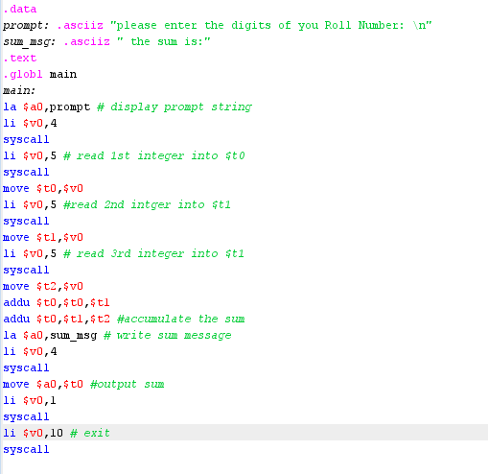*

*EXECUTION:*

*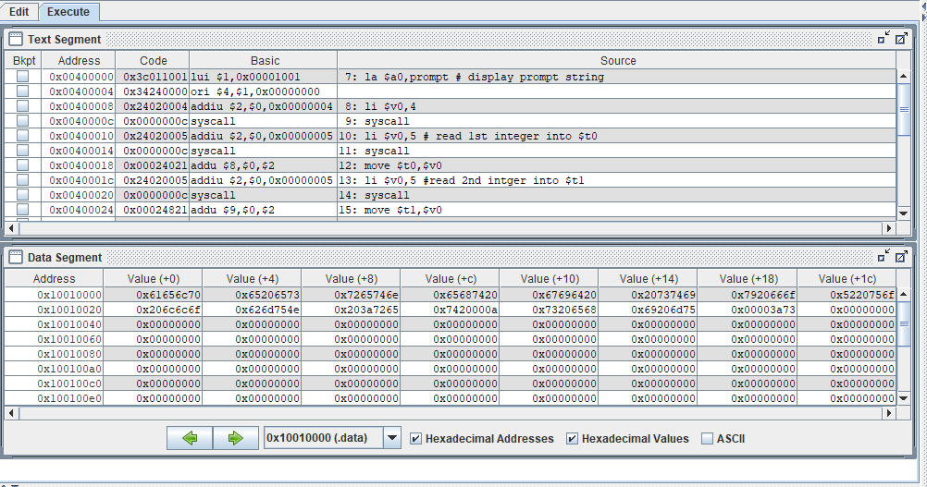*

*OUTPUT:*

*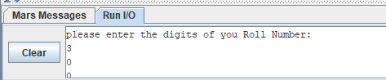*

**

*2. Write a MIPS Assembly program that Take first and last digits of your Roll Numbers and subtract them.*

*INPUT:*

*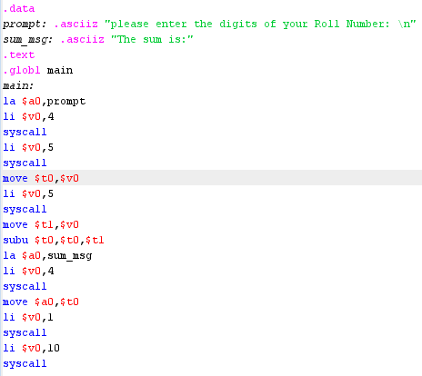*

*EXECUTION:*

*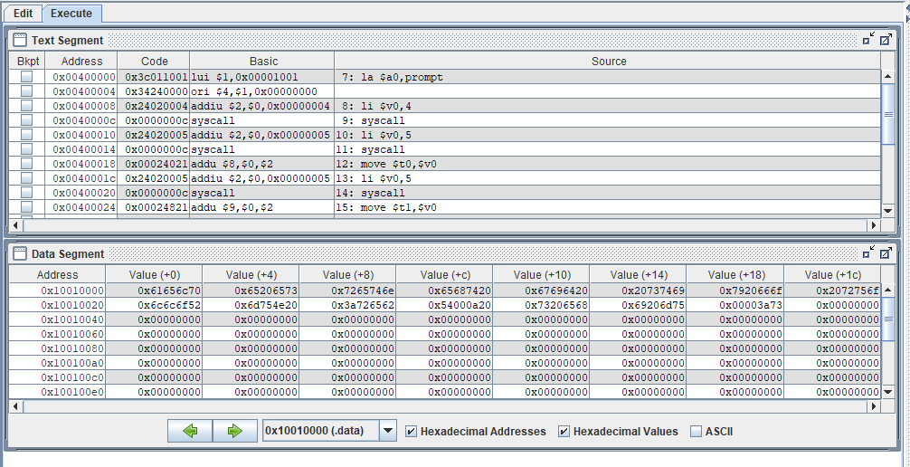*

*OUTPUT:*

*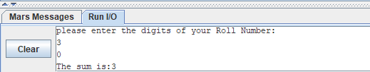*

*3. Write a MIPS Assembly program that takes an integer input and multiply that number with last digit of your roll number*

*INPUT:*

*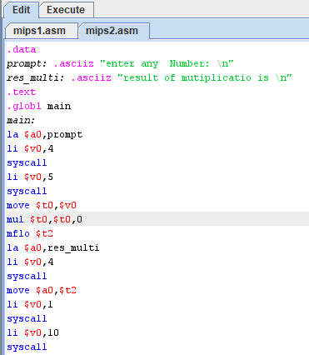*

*EXECUTION:*

*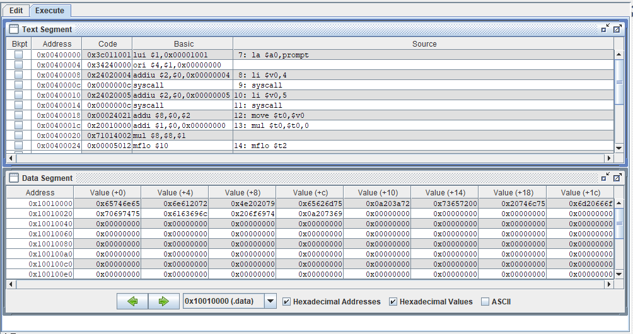*

*OUTPUT:*

*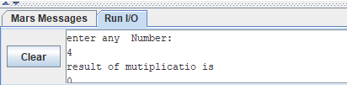*

*4. Write a MIPS Assembly program that takes your three-digit roll number as input and divide it with second digit of your roll number*

*INPUT:*

*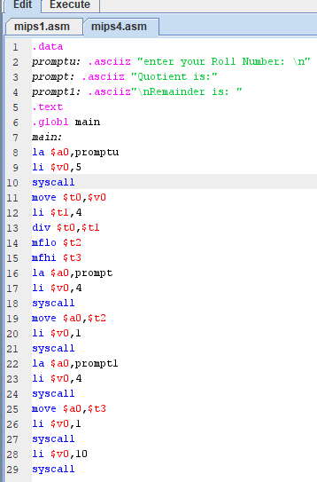*

*EXECUTION:*

*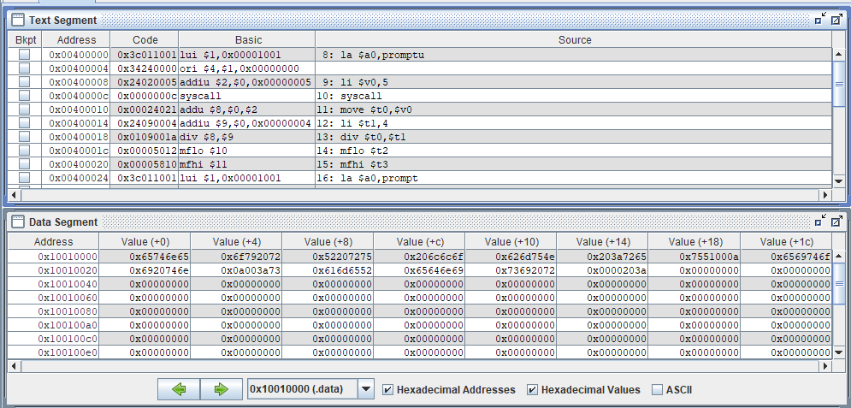*

*OUTPUT:*

*